**DAILY ONLINE ACTIVITIES SUMMARY**

|  |  |  |  |  |  |  |  |  |
| --- | --- | --- | --- | --- | --- | --- | --- | --- |
| **Date:** | **29/07/2020** | | | | | **Name:** | **NAIPUNYA VINOD NAIK** | |
| **Sem & Sec** | **IV SEM & A SECTION** | | | | | **USN:** | **4AL18CS050** | |
| **Online Test Summary** | | | | | | | | |
| **Subject** | | **OPERATING SYSTEMS DESCRIPTIVE TEST -2** | | | | | | |
| **Max. Marks** | | **30** | | **Score** | | | **N/A** | |
| **Certification Course Summary** | | | | | | | | |
| **Course** | **1) NLP BASIC COURSE FOR BEGINNERS**  **2)GIT GITHUB CRASH COURSE:LET’S GIT IT ON GITHUB** | | | | | | | |
| **Certificate Provider** | | | **1)UDEMY**  **2)UDEMY** | | **Duration** | | | **1) 1 HR**  **2) 2 HRS** |
| **Coding Challenges** | | | | | | | | |
| **Problem Statement: STRINGS PROBLEM STATEMENT HACKERRANK** | | | | | | | | |
| **Status:-EXECUTED** | | | | | | | | |
| **Uploaded the report in Github** | | | | | **YES** | | | |
| **If yes Repository name** | | | | | <https://github.com/naipunya-naik/Online-Coding-platform-coding/blob/master/Strings_29-07-2020.c> | | | |
| **Uploaded the report in slack** | | | | | **YES** | | | |

Online Test Details: (Attach the snapshot and briefly write the report for the same).

TODAY OPERATING SYSTEMS DESCRIPTIVE TEST-1 WAS CONDUCTED ON 29TH JULY 2020.

* SUBJECT:- OPERATING SYSTEMS
* CONDUCTED BY:- MRS. REENA LOBO
* FROM 9.30 AM TO 10:35AM
* DURATION:- 1 HR
* NO.OF QUESTIONS:- 4
* TOTAL MARKS:- 30
* MARKS WILL BE PROVIDED SOON
* I HAVE UPLOADED THE DOCUMENT ONTIME IN GOOGLE CLASSROOM.
* DUE TO GLITCH IN SETTINGS OF THE DUE TIMINGS, IT IS SHOWING TURNED IN LATE.
* 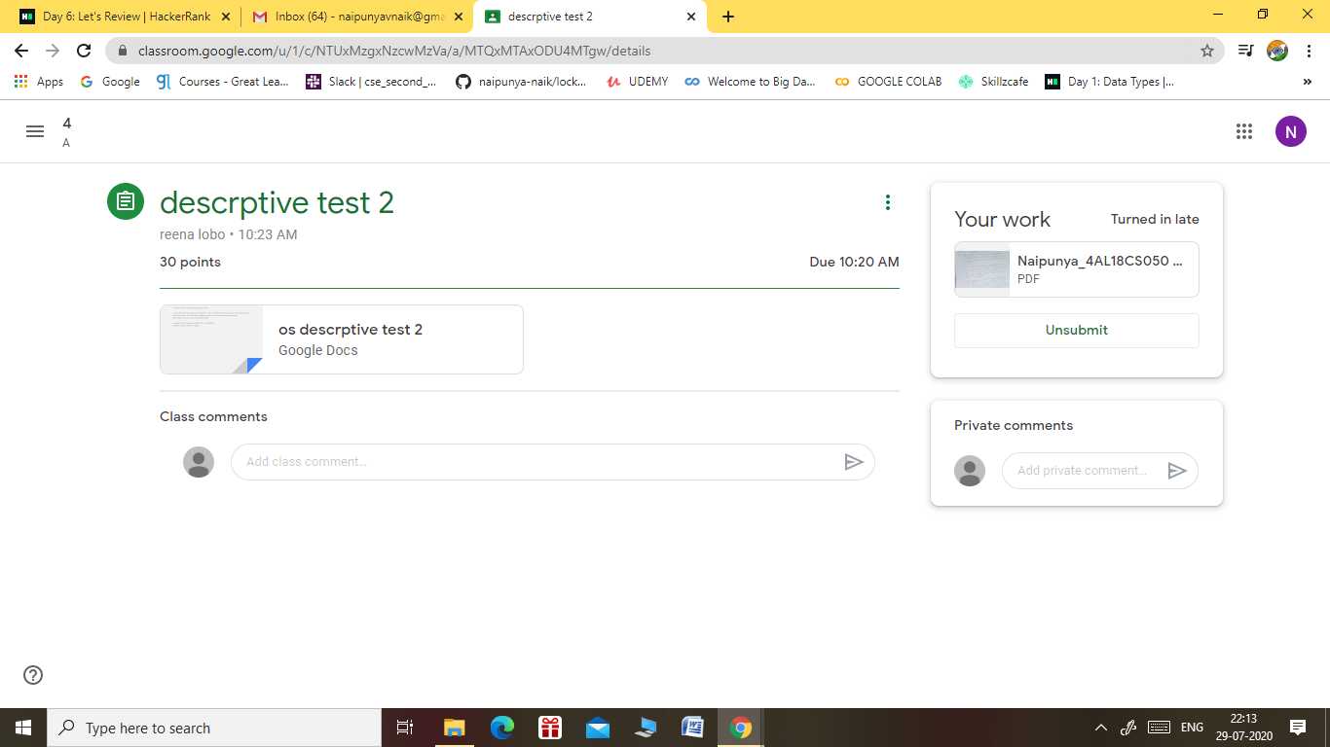

Certification Course Details: (Attach the snapshot and briefly write the report for the same).

CERTIFICATION COURSE NAME:- **NLP BASIC COURSE FOR BEGINNERS**



CERTIFICATION COURSE NAME:- **GIT GITHUB CRASH COURSE:LET’S GIT IT ON GITHUB.**



Coding Challenges Details: (Attach the snapshot and briefly write the report for the same).

**Task**  
Given a string, , of length  that is indexed from  to , print its *even-indexed* and *odd-indexed* characters as  space-separated strings on a single line (see the *Sample* below for more detail).

**Note:**  is considered to be an *even* index.

**Input Format**

The first line contains an integer,  (the number of test cases).  
Each line  of the  subsequent lines contain a String, .

**Constraints**

**Output Format**

For each String  (where ), print 's *even-indexed* characters, followed by a space, followed by 's *odd-indexed* characters.

**Sample Input**

2

Hacker

Rank

**Sample Output**

Hce akr

Rn ak

**Explanation**

*Test Case 0*:   
The *even* indices are , , and , and the *odd* indices are , , and . We then print *a single line* of  space-separated strings; the first string contains the ordered characters from 's *even* indices (), and the second string contains the ordered characters from 's *odd* indices ().

*Test Case 1*:   
The *even* indices are  and , and the *odd* indices are  and . We then print *a single line* of  space-separated strings; the first string contains the ordered characters from 's *even* indices (), and the second string contains the ordered characters from 's *odd* indices ().

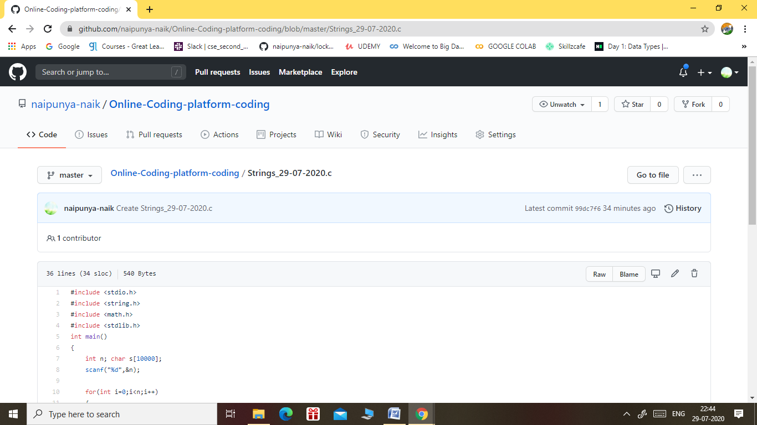

GITHUB REPOSITORY LINK:-

<https://github.com/naipunya-naik/Online-Coding-platform-coding/blob/master/Strings_29-07-2020.c>